(Approx. 419 words)

Open Source Lab
Tomboy Note-Taking Software
By Cal Esneault, former President of CCCC and leader of many Open Source Workshops & SIGs, Cajun Clickers Computer Club, LA
May 2014 issue, Cajun Clickers Computer News
www.clickers.org
ccnewsletter (at) cox.net

Searching the Internet you can find unexpected pages while looking for other specific topics. Later, when you try to find the accidental discovery again, you often can’t find it. Note-taking software is useful to help you save site links and organize them for later reference. Tomboy is a free and open-source software available for Linux, Windows, and MAC OS. It is the default application for Ubuntu and related distributions. Below is a screenshot of Tomboy on my Linux Mint 16 system. The left-hand panel displays all the notebook collections avaialbe. Clicking on any entry will give access to the individual notes which are organized as notebook sub-entries.



Clicking on “History Info” displays the note where I have pasted the URL’s of several interesting pages.

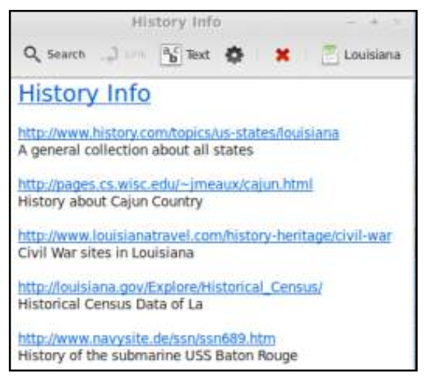
You can add explanatory text to describe the link, and clicking on the link opens your browser to tat web page. The notes are automaically saved to the Tomboy file which speeds up the annotation process.

You can copy any or all of the web page into a note, and Tomboy will append the URL to the end. Due to its bare-bones approach, Tomboy will not copy pictures (though you still have the link to retrieve them directly from the web site). A few text editing tools are available to annotate your note (font size and color, strike-through, etc.). A key feaure is the search function which finds text in either the heading or body of notes. Below is an example where “Baton Rouge” was found in 4 places, and the text found in this specific note is highlighted for ease of identification.

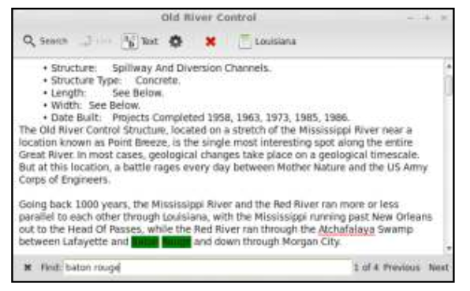

Note-taking software is useful for many other goals (to-do lists, meeting notes, etc.). The notebooks can be synchronized among several computers, you can also sync your notes to get easy viewing and managing of the notes with mobile devices (Android, iOS). Tomboy is part of the GNOME desktop environment. A more powerful note-taking application for the KDE environment is Basket (it allows importation of images and photos).

There are several more powerful note-taking programs available, such as OneNote (Microsoft Office), Evernote (from Evernote Corp.), and NeverNote (open-source). Key differential points for Tomboy are it is simple, it is the default for GNOME-based platforms, and it is tailored to work with Linux systems more seamlessly.




